# Benthic monitoring summary: southern Mariana Islands 2017

## About this summary brief

The purpose of this document is to outline the most recent survey efforts conducted by the Coral Reef Ecosystem Program (CREP) of the NOAA Pacific Islands Fisheries Science Center as part of the long-term monitoring program known as the Pacific Reef Assessment and Monitoring Program (Pacific RAMP). More detailed survey results will be available in a forthcoming status report.

## Sampling effort

* Ecological monitoring took place in the Northwestern Hawaiian Islands from   
  August 29, 2016 to September 30, 2016.
* Data were collected at 182 sites. Surveys were conducted at Kure Atoll (*n* = 39), Pearl and Hermes Reef (*n* = 56), Lisianski (*n* = 40), and French Frigate Shoals (*n* = 47).
* At each site, the fish assemblage was surveyed by underwater visual census and the benthic community of the reef was assessed.

## Overview of data collected

Maps of Kure, Pearl & Hermes, Lisianksi, and French Frigate survey areas. Fish biomass at each site is indicated by red circles showing grams of biomass per square meter, ranging from 1 to 1,392 grams per square meter.

Figure 1. Mean total fish biomass at sites surveyed.

Maps of Kure, Pearl & Hermes, Lisianksi, and French Frigate survey areas. Percent coral cover at each site is indicated by yellow circles, ranging from 0 to 57 percent cover.

Figure 2. Mean hard coral cover at sites surveyed.

Biomass of piscivores, secondary consumers, primary consumers, planktivores, and a total of all fishes, is shown in grams per square meter for each island site: Pearl & Hermes, French Frigate, Lisianski, and Kure.

Figure 3. Primary consumers (pri. cons.) include herbivores (which eat plants) and detritivores (which bottom-feed on detritus), and secondary consumers (sec. cons.) are largely omnivores (which eat a variety of fish and invertebrates) and invertivores (which eat invertebrates).

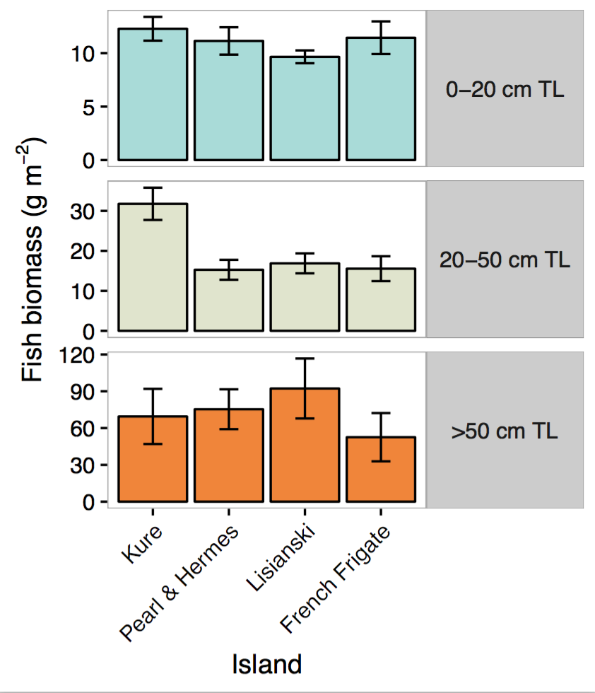

Figure 4. Mean fish biomass per size class (± standard error). Fish measured by total length (TL) in centimeters (cm).

## Spatial sample design

Survey site locations are randomly selected using a depth-stratified design. Logistic and weather conditions factor into the allocation of monitoring effort around each island or atoll. The geographic coordinates of sample sites are then randomly drawn from a map of the area of target habitat (hard-bottom reef) per study area (typically an island or atoll or, in the case of larger islands, sectors per island), within the depth strata of shallow (0-6 m), mid (6-18 m), and deep (18-30 m).

## Sampling methods

A pair of divers survey the fish assemblage at each site using a stationary-point-count method (Fig. 5). Each diver identifies, enumerates, and estimates the total length of fishes within a visually estimated 15-m- diameter cylinder with the diver stationed in the center. These data are used to calculate fish biomass per unit area (g m-2) for each species. Mean biomass estimates per island are calculated by weighting averages by the area per stratum. Island-scale estimates presented here represent only the areas surveyed during this cruise.

Each diver also conducts a rapid visual assessment of reef composition, by estimating the percentage cover of encrusting algae, fleshy macroalgae, and hard corals in each cylinder. Divers also estimate the complexity of the reef structure, and take photos along a transect at each site that are archived to allow for future analysis.

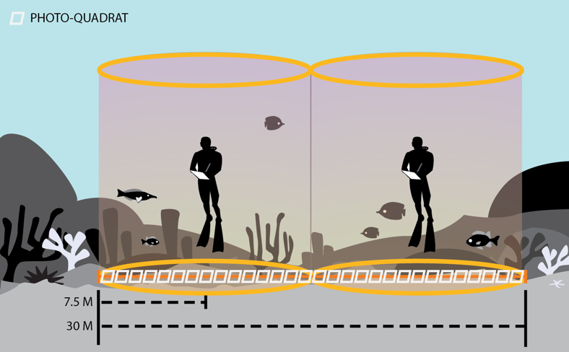

Figure 5. Method used to monitor fish assemblage and benthic communities at the Rapid Ecological Assessment (REA) sites.

## About the monitoring program

Pacific RAMP forms a key part of the National Coral Reef Monitoring Program of NOAA’s Coral Reef Conservation Program (CRCP), providing integrated, consistent, and comparable data across U.S. Pacific islands and atolls. CRCP monitoring efforts have these aims:

* Document the status of reef species of ecological and economic importance.
* Track and assess changes in reef communities in response to environmental stressors or human activities.
* Evaluate the effectiveness of specific management strategies and identify actions for future and adaptive responses.

For more information

Coral Reef Conservation Program:

  http://coralreef.noaa.gov

NMFS Pacific Islands Fisheries Science Center:

http://www.pifsc.noaa.gov/

CRED publications:

http://www.pifsc.noaa.gov/pubs/credpub.php

CRED fish team:

http://www.pifsc.noaa.gov/cred/fish.php

Fish team lead:  ivor.williams@noaa.gov